

Our Learning Journey

We will start by settling the children into Nursery and helping them to learn the nursery routines that are so important to their days. These include supporting children’s play with and alongside their new friends, beginning to tidy away their toys, stopping and sitting for snack time, using the bathroom or lining up to go and play outside. Lots of things to take in!

We will begin to find out all about your children, what they can do and what they enjoy doing. It will be so lovely getting to know them all.

It is so lovely getting to know you and your children and myself and Miss Graham would first of all like to thank you for supporting us with our first few week’s induction timetable. Your child starting nursery is a massive transition and the plan we have to increase their time in class over 2-3 weeks will support them in this transition.

**Nursery Autumn 1 Newsletter**

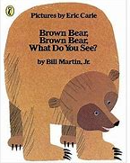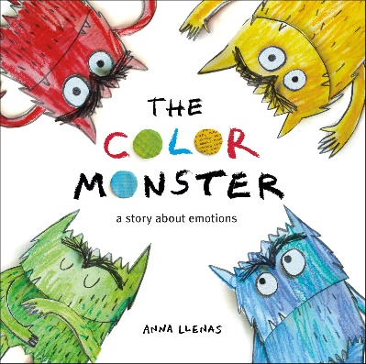

In the entrance to Nursery there is an information board which holds important information. We will update the board on events that are happening or things you need to know about.

If you have any questions, concerns or feedback please speak to myself of Miss Graham.

How can you help your child?

Count as much as possible - counting objects, fruit in a fruit bowl, numbers in the environment. Sing their nursery songs and the songs of their friends. Share stories as much as possible.

Once the children are settled we will send home picture books – they can look through the pictures, make up stories based on the pictures or listen to a grown up (or older sibling) read the story to them.

What the children will be learning;

We start the year by helping the children develop a sense of belonging. They will become familiar with their nursery picture - colouring it in or singing their nursery song. They will also be getting to know the names of the other new children in nursery. We will share stories with colours as a theme to develop recognising colours before We will be starting early phonics by playing listening games and early counting during milk time and other nursery routines.