Hello everyone and welcome back to school! I hope you are all feeling refreshed after a lovely summer break and that you are raring to go for the year ahead. The first term back at school is always a long term and it takes time to get used to our new surroundings. Lots will be happening this term so please have a read through below about what we can expect from Year 3 in the lead up to the end of term.
Maths  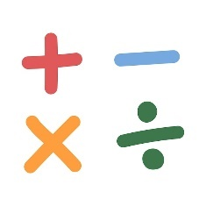  To begin the term, we will be looking at practicing our fundimental skills. We will place an emphasis on addition and subtraction and finding different strategies in which we can add or subtract three different numbers. Following on from this, we will be focussing on place value. We will be breaking down numbers upto 1,000 into hundreds, tens and ones as well as bridging 100 by adding and subtracting multiples of 10.  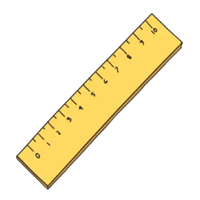  To end the term, we will then be learning to record in tables and measure different lengths. The children will use estimations and then measure height and length in centimetres and metres. We will then convert centimetres into metres and millimetres into centimetres.  Throughout this learning, we will also be continually looking at the times tables and specifically the 2, 5 and 10-times tables so that the children become secure with those. We will also have lessons where we focus on problem solving where the children will have opportunities to use their problem-solving skills to find the answers. | English  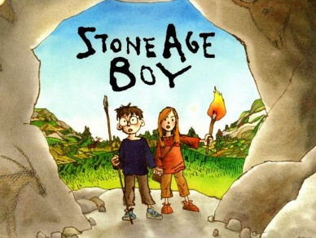  To begin the term, we will be focusing on a book called ‘Stone Age Boy’ and the children will create their own version of events from the story before they make their own fantasy/ adventure story. This story offers lots of insight into what life may have been like during Prehistoric Britain, which links in with our history, art and science topics.  Reading  Each day we will have a reading and phonics session in a morning. On a Monday and a Friday, we will be reading our class book which the children will help vote for and throughout the week we will either be in phonics groups, for those children who require more practice with their sounds or take part in a short comprehension task. This will entail reading and answering questions on an unfamiliar text. As we progress through the year, the children will become more fluent and confident in being able to independently answer these questions.    Useful information and key dates  Every Tuesday and Thursday – P.E (please bring in kits)  Every Friday – Spellings test in school and new spellings go home.
Curriculum
Our P.E days for the first term are Tuesday and Thursday. On a Tuesday, we will be covering dance with a coach, and the theme of the music will be from the film Matilda. On a Thursday, we will be practicing our football skills, specifically passing, dribbling and shooting. In history, the children will be learning about the Stone Age and the different eras. To help with this, the children will also cover the Stone Age during English and art, where they will create charcoal animals, a prehistoric paint palette and much more. We are also lucky enough to have Mr. Mingstones work with us in the forest school for these art lessons. In R.E, we will be looking at forces, friction and magnets. The children will have lots of practical experiments to conduct and they will find out which materials are magnetic. In R.E, we will be learning about what makes us human, in computing we will be learning about computer systems and networks and finally, in P.S.H.E, we will look at ourselves and what relationships we have.

Year 3 – Autumn 1

