|  |  |
| --- | --- |
| Welcome back! We hope you have had a nice break and your children have settled into Year 6. | |
| Plus minus multiply divide mathematical symbols Vector Image**Maths**  We will be learning all about place value and the composition of numbers and decimals.    We are then moving on to multiplication and division, focussing on mental methods.  We will conclude this half term with multiplication and division using formal methods. | **English – Writing**  In writing, we are reading ‘Holes’ by Louis Sachar and we will be focussing on character studies and varying points of view. We will complete explanation texts to include humour and irony and then describe settings to match a mood (pathetic fallacy)  **English – Reading**  We will be enjoying a wide variety of texts this year. This term, we will read ‘Skellig’ by Geordie author David Almond.  **How can I help?**  Please ask your child about their opinions on what they have read, maybe a trip to the local library to borrow additional books by authors they have enjoyed. |
| The World Around Us**Curriculum**  We are learning all about crime and punishment in history. Ask your child to observe what they see around them. Discuss what is in the news. In science, we are studying classification of living things. We will be looking at how living things are sorted, and discussing their similarities and differences.  In P.E. we will all attend swimming lessons where coaching will be for all levels of confidence and skill! | |

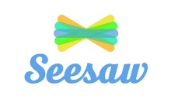 **Autumn 1 – Year 6**

**Parents must be able to access Seesaw**. Children should have brought home codes for parents to log on. If you don’t currently have Seesaw, please speak to me as soon as possible.

**Practice SATs Tests:**

SATs week begins **in May;** however, children will have regular practice tests. These will be past papers so the children get used to the test and test conditions. Please do not worry as the children will be very well prepared for the real thing!

**P.E.**

**Swimming will be every Tuesday. Children will need a towel, a suitable swim outfit and a plastic bag to keep their wet gear in.**

**Swimming shorts must not pass below the knee. Girls’ kits must be all in one. Swim caps and goggles are allowed.**

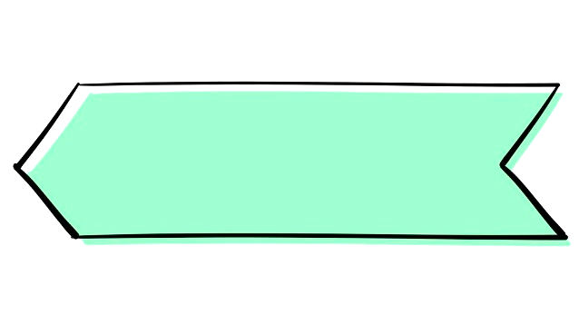

**Useful Information**