Miss Hind and I would first of all like to welcome you all onto our Reception adventure. We had a fabulous start with your little one and we can’t wait to spend the next academic year together! We hope you had a lovely summer break and we look forward to seeing what the Autumn term will hold.

**Reception Newsletter**

Our journey begins…

The children made such an amazing start to Reception last week and we hope that they came home with lots to tell you. We are hoping to begin our ‘parent engagement’ activities which will include a 5-10 minute activity with your child each morning. These activities will vary from cutting activities, name writing and our library day on a Friday. We hope you are able to join up for a short time to support your child with their learning.

Our Learning

****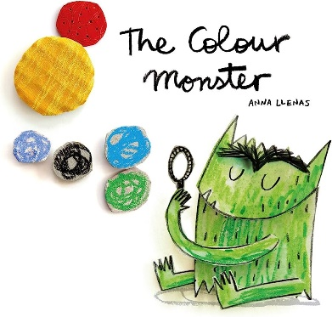

Our Learning

Please use the QR code that Miss Hymers has provided to join our class Seesaw where we will set weekend tasks as well as being able to see what we get up to throughout the day.

A gentle reminder that we provide cups so water bottles are not required. Also, can I ask that all toys are kept at home.

If you have any worries or concerns, please speak to myself or Miss Hind.

Our Learning

How can you help your child?

Share stories as often as possible – talking about what is happening, characters, emotions and making predictions for what they think is going to be happening next.

Explore number in day to day activities for example, counting fruit in your fruit bowl or how many cars are in a line and comparing quantities, modelling vocabulary such as more and fewer.

**Useful Information**

What the children will be learning…

The children will be sharing lots of stories about what makes them special and unique as well as how to best manage their emotions, for example, a story we will focus on is ‘The Colour Monster’. We will be exploring how we are different to our peers. We will become excellent mathematicians by measuring one another and counting objects and each other. We will be beginning our phonics journey as we begin to teach Phase 2 phonics following our Little Wandle scheme. The children will continue to explore the indoor and outdoor provision as it evolves and develops to meet their learning needs.